# Mouth & Oesophagus

## Mouth

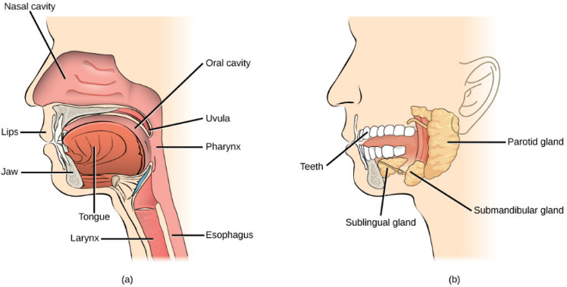Like any other food, The mechanical breakdown of spaghetti noodles in the mouth, where teeth ground up the pasta to expand its surface area so it may be chemically broken down, is the first step in the digestion of pasta. A type of chemical digestion also takes place in the mouth cavity. Saliva coats the pasta for two reasons: to coat it with enzymes (salivary amylases) that begin to dissolve the pasta's carbohydrates, and to provide a slippery coating for the masticated pasta to glide down the 10-inch oesophagus and into the stomach.

## Oesophagus

<https://s3-us-west-2.amazonaws.com/courses-images/wp-content/uploads/sites/1223/2017/02/07185052/Figure_34_01_08ab-1024x518.jpg>

After the amylase in the mouth has broken down some of the carbs, the meal is moved to the throat by muscle movements from the mouth and tongue. It is forced down the oesophagus, a tube that connects the mouth and the stomach, from the throat. A bolus is the passage of the food + saliva down the oesophagus. The bolus is pushed down the oesophagus and into the stomach by waves of muscle contractions known as peristalsis.

# Stomach

The stomach is the final stop for mechanical digestion and the initial stop for protein digestion. The gastric acid in the stomach chemically breaks down the pasta. The carbohydrates stop digesting once they reach the stomach because the amylase enzymes do not function in the acidic conditions of the stomach. The pasta then moves through the sphincter into the duodenum. Pasta spends roughly 30 to 60 minutes in the stomach

# Small Intestines

<https://thumbs.dreamstime.com/b/stomach-diagram-illustration-58112999.jpg>

## Breakdown

Small intestine (breakdown) Large food molecules are broken down into chemical building blocks through chemical digestion, which can then be absorbed through the intestinal wall and into the general circulation. The digestive juice produced by the pancreas contains enzymes that break down carbohydrates, lipids, and proteins. The pancreas sends digestive juice to the small intestine by ducts, which are tiny tubes.

Carbohydrates are chemically broken down in the small intestine rather than the stomach. The chemical breakdown of digestible carbohydrates is completed by pancreatic amylase and disaccharidases. The monosaccharides are absorbed and transported to the liver through the circulation. . . . . . . . . . . . . . . . . . . . . . . . . . . . . . . . . . . . . . . . . . . . . . . . . . . . . . …]’-

## Absorption

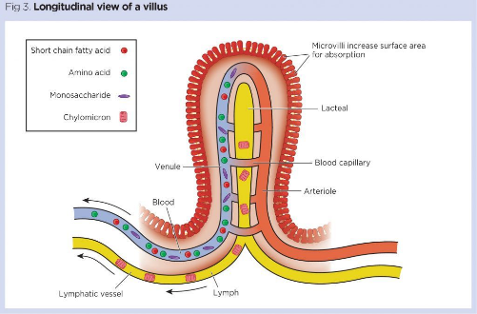The partially digested pasta combines with stomach juices and passes through the pyloric sphincter into the duodenum, the first region of the small intestines, where the majority of the chemical digestion of carbs and lipids takes place. Villi line the inside walls of the intestines, which contain blood vessels that absorb the results of carbohydrate and protein digestion. Lacteals are lymphatic channels in the villi that absorb lipids from the pasta. The duodenum absorbs secretions from the liver, gallbladder, and pancreas (mainly bile, which chemically digests the fats in pasta, a process known as emulsification) (primarily carbohydrases, proteases, and lipases that chemically digest all three macromolecules). The duodenum connects to the jejunum and ileum, two other small intestinal sections. Roughly 40 to 120 minutes spend in the intestines, sometimes longer . . . . . . . . . . . . . . . . . . . . . . . . . . . . . . . . . . . . . . . . . . . . . . . . . . . . . . . . . .

[https://cdn.ps.emap.com/wp- content/uploads/sites/3/2019/08/Fig-3-Lonitudinal-view-of-a-villus-1024x675.jpg](https://cdn.ps.emap.com/wp-%20content/uploads/sites/3/2019/08/Fig-3-Lonitudinal-view-of-a-villus-1024x675.jpg)

# Material breakdown & use

Carbohydrates, dietary carbohydrates are digested to glucose, fructose and/or galactose, and absorbed into the blood in the small intestine. You don't experience the energy spikes associated with simple sugars since pasta is a great source of complex carbs, which release energy slowly and steadily.

# Large Intestines

The remaining pasta travels to the large intestines via the ileocecal valve, where bacteria might further digest the pasta's wastes, perhaps resulting in gas, and where some water may be reabsorbed. Pasta waste passes through the cecum first, then the ascending colon, transverse colon, descending colon, sigmoid colon, rectum, and ultimately the anal canal as faeces, before exiting the body. Because the large intestines lack villi, the pasta cannot be reabsorbed into the bloodstream once it reaches them. Pasta spends roughly 47 hours for women and 33 hours for men in the large intestine.

<https://cdn.ps.emap.com/wp-content/uploads/sites/3/2019/09/Fig-1-Anatomy-of-the-large-intestine-1024x891.jpg>

# Elimination & Faeces

It's mostly water weight at first, though. This is mostly because cutting carbs also wipes out the glycogen stores in your muscles. Glycogen helps your body retain water. You may also lose some salt along with the carbs you cut out.

# References

* IFFGD. 2022. *The Digestive System - IFFGD*. [online] Available at: <https://iffgd.org/gi-disorders/the-digestive-system/> [Accessed 8 May 2022].
* *howdoespastagothroughthedigestivesystem? - adelaidejcole*. Sites.google.com. (2022). Retrieved 8 May 2022, from [https://sites.google.com/s ite/adelaidejcole/howdoespastagothroughthedigestivesystem%3F](https://sites.google.com/s%20ite/adelaidejcole/howdoespastagothroughthedigestivesystem%3F).
* *The Digestion Process of Pasta*. prezi.com. (2022). Retrieved 8 May 2022, from <https://prezi.com/jrkah7ctry7h/the-digestion-process-of-pasta/?frame=cd46a0d818bc739aed7b97b192f2c3b3c60a9a6e>.
* *3.3: Digestion and Absorption of Carbohydrates*. Medicine LibreTexts. (2022). Retrieved 9 May 2022, from <https://med.libretexts.org/Courses/American_Public_University/APUS%3A_An_Introduction_to_Nutrition_(Byerley)/APUS%3A_An_Introduction_to_Nutrition_1st_Edition/03%3A_Carbohydrates/3.03%3A_Digestion_and_Absorption_of_Carbohydrates#:~:text=Carbohydrates%20are%20not%20chemically%20broken,and%20delivered%20to%20the%20liver>.